Integrating Sonarqube with Jenkins by Docker containers

Pre-requisites:

* One vm for Jenkins, other for Sonarqube
* Machine with 2GB RAM
* Java 1.8, Docker, Sonarqube 7.7

Installing Docker and pulling Jenkins image in VM1(jenkins image):

# yum install -y java-1.8.0-openjdk

# yum install -y docker

# service docker start

# service docker restart

# docker pull jenkinsci/blueocean

# docker run -p 8080:8080 jenkinsci/blueocean

(copy the password)

Browse ipaddress:8080

Now jenkins is up and running.

* Install sonarqube plugin.

Manage jenkins -> manage plugins -> available -> sonarqube scanner and Maven Integration.

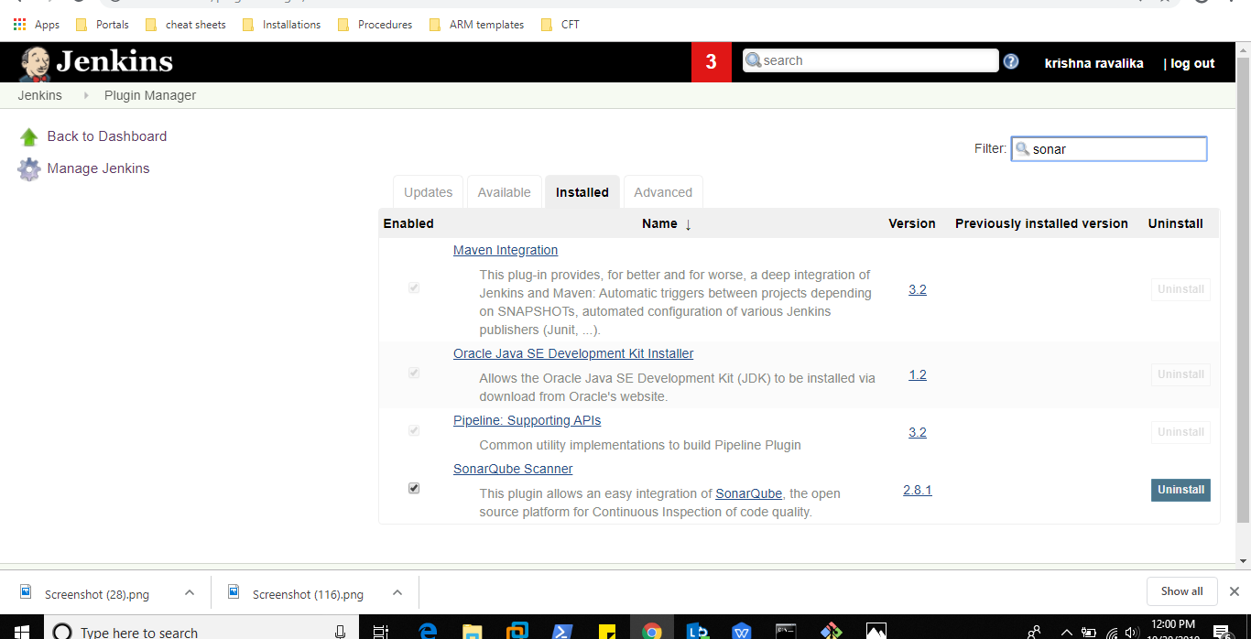

* Install tools

Manage Jenkins -> Global Tool Configuration ->

Java , git, sonarqubescanner , maven

Give JAVAPATH as usr/lib/jvm/java/java-1.8.0-openjdk

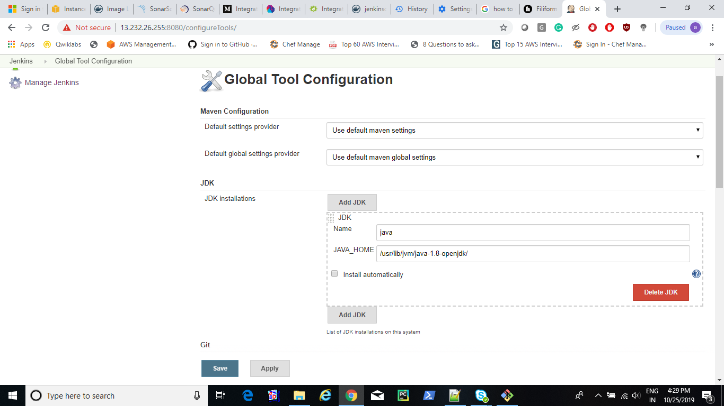

Installing Docker and pulling sonarqube image in VM2(sonarqube image):

# yum install -y java-1.8.0-openjdk

# yum install -y docker

# service docker start

# service docker restart

# docker pull sonarqube

# docker run -d --name sonarqube -p 9000:9000 sonarqube

Now sonarqube is up and running.

Browse ipaddress:9000

Default username : admin

Password : admin

In sonarqube:

Create new project

Generate token

Give the project language as java

Now command will be generated. Copy the command

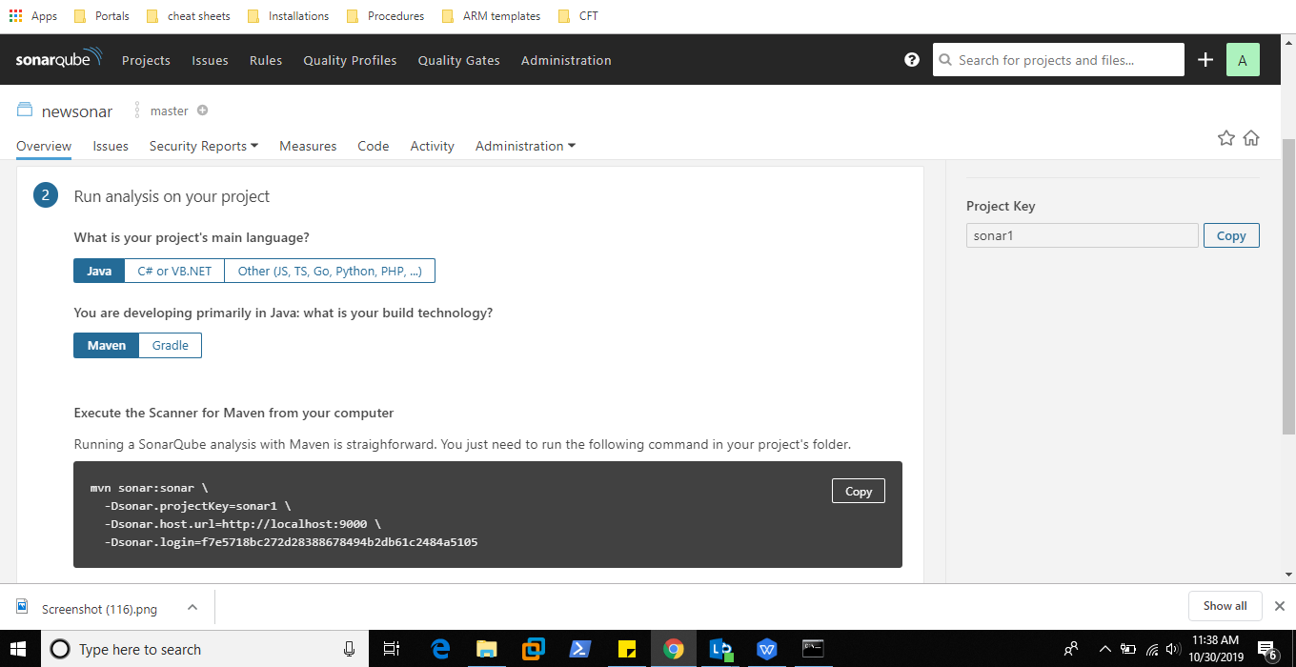

In jenkins:

* Configuring system

Manage Jenkins -> Configure System-> sonar server

Give the ipaddress of sonarqube server with port (http://sonaripaddress:9000)

Give the secret key as generated in sonar server

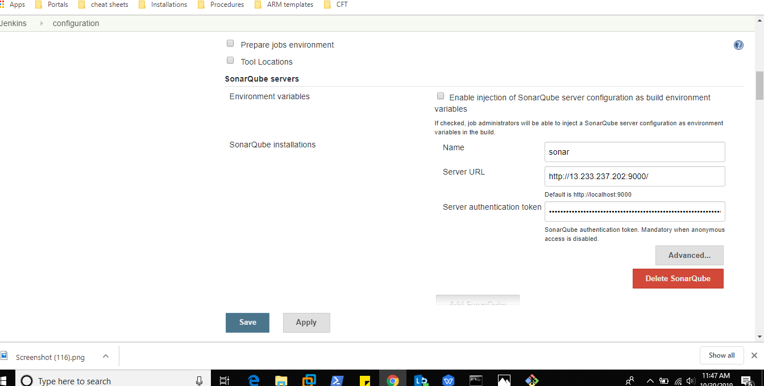

* Build Job

NewItem -> Name(sonar) -> Maven Project -> ok

Git url : <https://github.com/SonarQubeCommunity/sonar-l10n-zh.git>( example project)

Build Step -> Execute Shell -> Paste the command generated by sonarqube -> ok

Build Job

* Now the project will be successfully built
* Check the reports in the SonarQube Dashboard

